The multiThreshold guide to getting started

multiThreshold is a flexible piece of computer software suitable for measuring many aspects of hearing both in the clinic and in the laboratory. This guide will get you started on three of the most useful measurements: absolute thresholds, frequency selectivity and compression.
This guide assumes that you are much too busy to read manuals and want to get started now. It also assumes that you have already downloaded the software and also know what an absolute threshold is.

Absolute threshold measurement
- multiThreshold runs in MATLAB on a PC, so the first thing to do is to launch MATLAB.
- Now move to the folder multiThreshold 1.46 in the MAP1_14 folder. Only you know where you put that folder.
- Run EXPGUI_MT by typing in the command window: run ExpGUI_MT
- You should now see the graphical user interface (GUI)
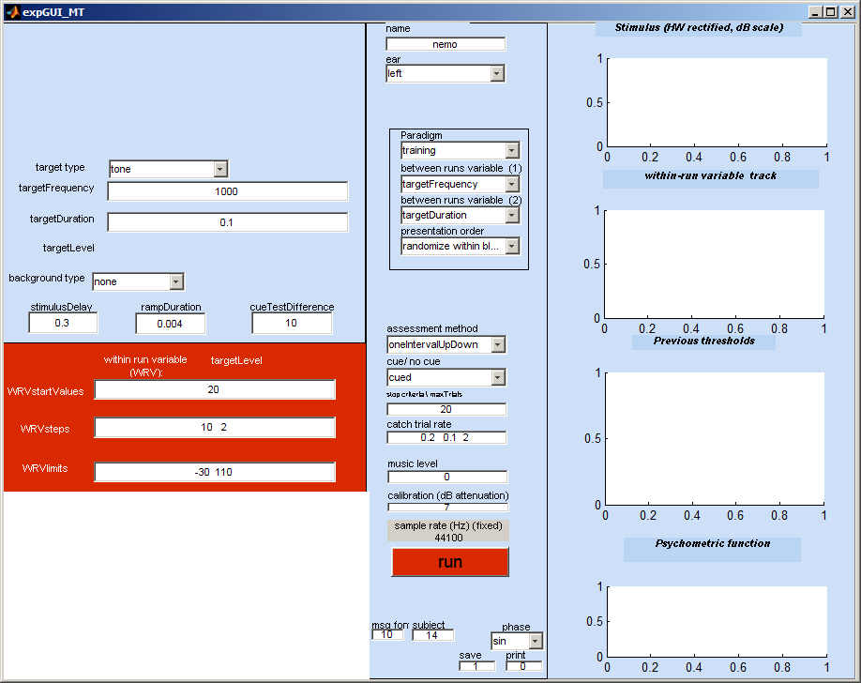
- You are ready to start making measurements. Plug your headphones into the computer headphone socket but before you do this adjust your audio output level to maximum. Your computer will not yet be calibrated to give correct decibel sound pressure levels (dB SPL) but we can still get a general idea of how the software works.
- The GUI is set up by default to make an absolute threshold measurement at 1 kHz using a 100-ms tone. You can start now by clicking on the run button. A new GUI (called the subject GUI) should appear. Move this box so that you can see both GUIs at the same time. When measuring a client’s hearing the subject GUI should ideally be on a separate screen so that he/she cannot see the ExpGUI that you are using to control the process. However, that does not matter for the present.
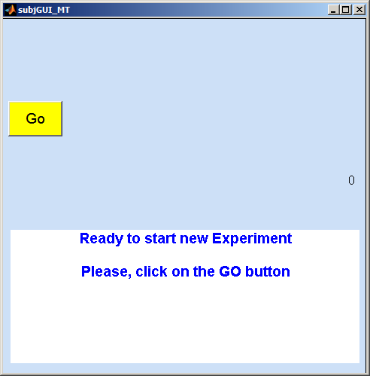
- You are now the patient/ subject/ guinea pig. To start the process off, click on the ‘Go’ button. You should immediately hear two beeps. After the beeps the GUI will present a number of click boxes
- Click on the number that corresponds to the number of clicks you heard. Hopefully, on this occasion, this number will be ‘2’. If you do not hear two clicks you might have a problem with your computer or your computer might be producing beeps that are too quiet to be heard. If that is the case you can request louder sounds by increasing the number in the box called WRVstartValues in the red section of the experimenter GUI. By default this is the number ‘30’ which should produce a 30-dB SPL tone. If your computer is not yet calibrated we do not know exactly what level of sound it is producing. We can live with this for the moment by putting a bigger number in the box (say 60) and restarting the run by clicking agin on the ‘run’ button.
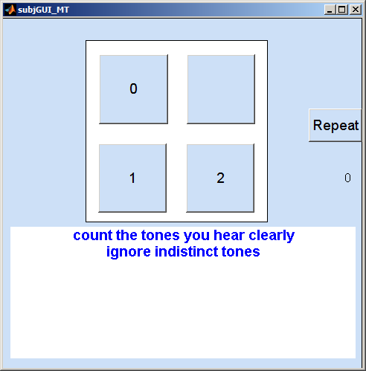
- Because you are currently both the experimenter and the subject, you will be able to see a picture representing the stimulus in the top-left hand corner of the experimenter GUI. This should show two pulses representing the tones you (hopefully) just heard. This allows you to see what the subject is hearing.
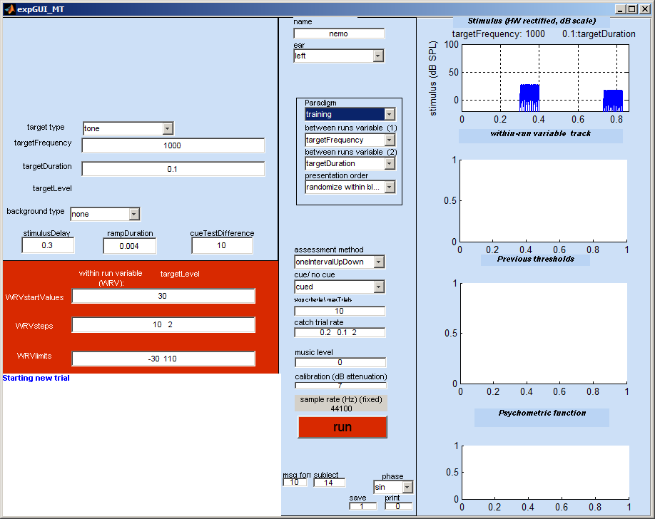
- When you make your first choice by clicking on one of the numbers, the software will soon after generate the next stimulus. The second stimulus is a ‘catch trial’; a trial when the second tone is not presented. The upper-right panel will look like the picture below. Catch trials are a check that the subject understands the instructions and is not imagining that he hears things when they are not present. The second trial is always a catch trial for a number of reasons. First, it gives an early check that all is well and that the subject can follow the instructions. Second, it illustrates the fact that there are trials when the second tone is not present and third, it give the subject an auditory memory of what a single tone sounds like. Perhaps this is not necessary when counting simple tones but it can be quite helpful in other paradigms when the stimuli are more complex.
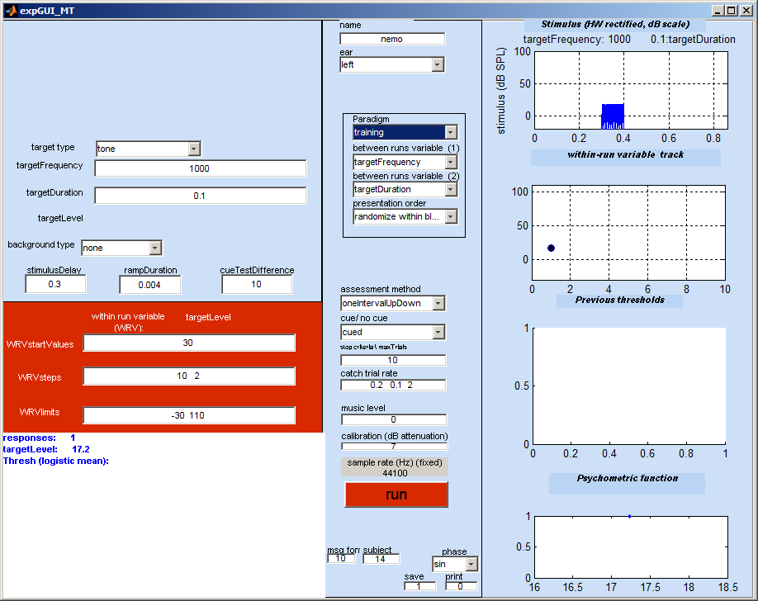
- Hopefully, you will now agree to click on the ‘1’ button because only one tone was present and you should not have heard two. After this, the software will generate a new stimulus which might be another catch trial but, more likely will be a proper test trial with two tones. At this point it is worth introducing some terminology. When there are two tones, the first tone is called the ‘cue’ tone and the second is called the ‘test’ tone. The purpose of the cue tone is to wake the subject up and remind him of what the test tone sounds like. It is exactly the same as the test tone except that it is deliberately made easier to hear. In this paradigm it is easier to hear because it is more intense (10 dB more intense to be precise) than the test tone which follows. We are not really interested in whether the subject hears the cue tone because we know that he always will but we include it in the tone count. Our interest is focussed on the test tone which, in this case, is quieter. If the subject clicks on the ‘1’ button on a regular trial, we assume that he has heard the cue but not the test tone.
- The measurement now proceeds on an up and down basis. If the test tone is heard (button ‘2’ clicked), its intensity will be increased in level on the next trial. If it is not heard (button ‘1’ clicked), its intensity will be decreased in level on the next trial. This up and down process will generate a ‘track’ that is displayed on the experimenter GUI in the second figure down on the right.
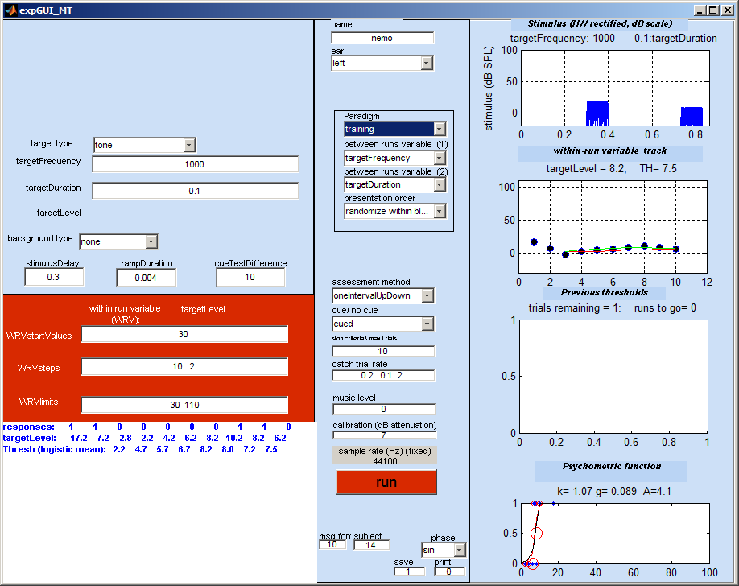
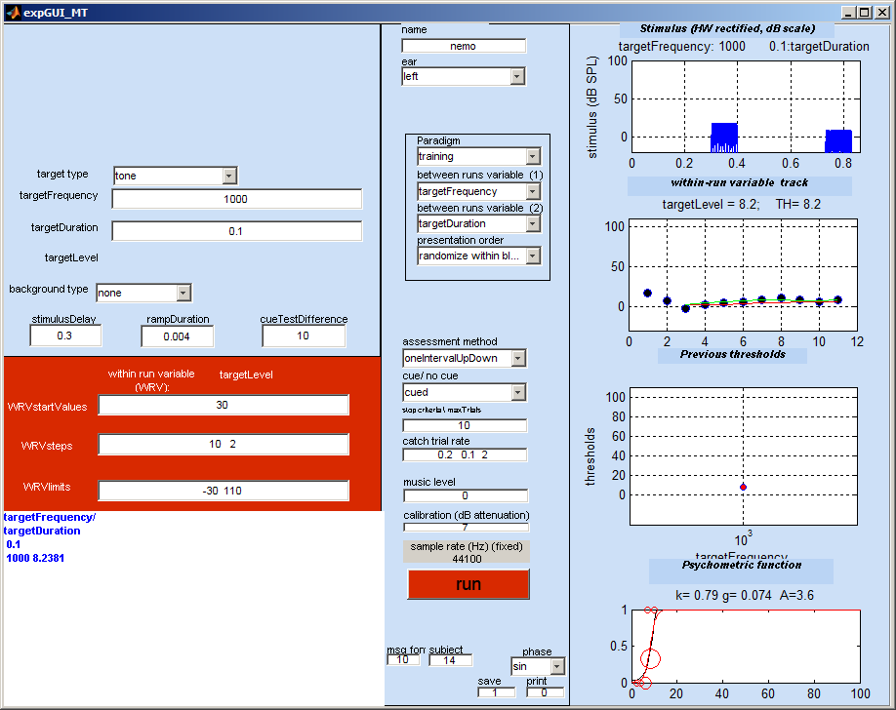
- This will continue for 10 trials plus the few trials up to the first reversal. After this the software will announce the end of the run by playing ‘tada’ over the headphones. The threshold is then computed as (roughly) the average of the levels of the tones heard. This will be displayed on the third figure down on the experimenter GUI figure and the result will also be printed out in the command window.
******** multithreshold version 1.46

Name: nemo
paradigm: training
Ear: left
method: oneIntervalUpDown/ withCue
date: 10-Sep-2011 18_46_01

thresholds
targetFrequency/ targetDuration
0.1
1000 8.2381

- And that concludes the first threshold measurement.

Multiple absolute measurements
The guiding principle of multiThreshold is the ‘paradigm’. In the last example, the paradigm was ‘training’. The paradigm is indicated in the pull-down menu with the same name near the centre of the GUI. This guide introduces three other paradigms: ‘absThresholds’, ‘IFMC’ and ‘TMC’. These are otherwise known as ‘absolute thresholds’, ‘tuning curves’ and ‘compression’. In this section we shall concentrate on absolute thresholds.
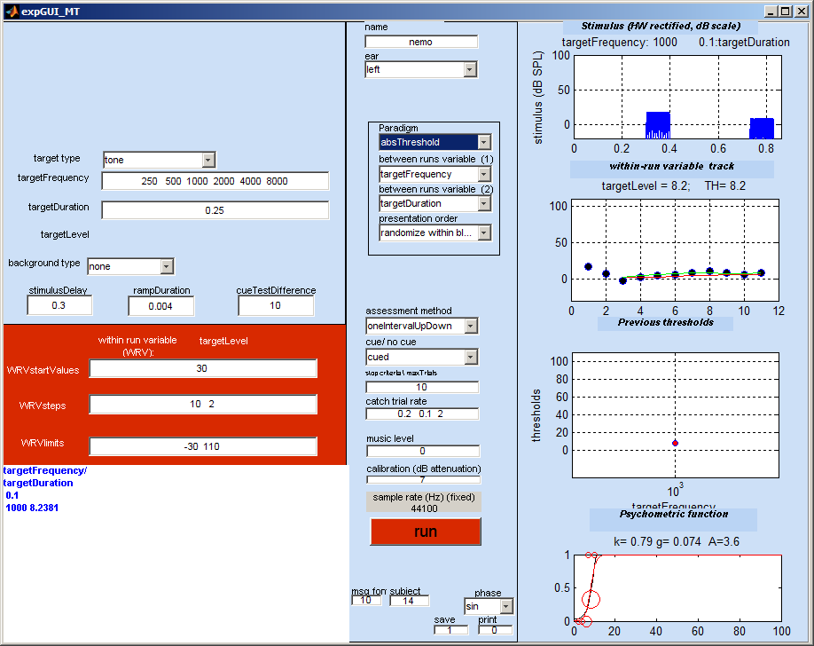
- Select the paradigm ‘absolute thresholds’ from the pup-up menu. You will notice that many changes occur on the experimenter GUI. This sets up the parameters for the testing ahead. The frequencies to be tested should now appear in the ‘targetFrequency’ box. The ‘targetDuration’ is also set (at 0.25 s). The test is ready to begin.
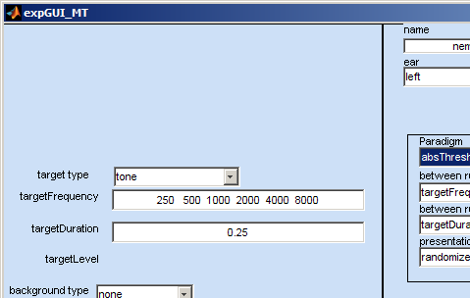
- Click on the run button and the test will start. The procedure is the same as described above. The only difference is that a number of threshold measurements will be made in succession. At the end of each threshold measurement, a trill will sound and the subject GUI will revert back to the image with the ‘GO’ button. To move on to the next test, you must click on this button.
- The measurements will be made in random order but at the end of the series, the experimenter GUI should display all of the thresholds in graphical form and the results will be printed out in the command window. The command window offers a complete description of the session but the important bits (the thresholds) are printed at both the top and the bottom of the print out.
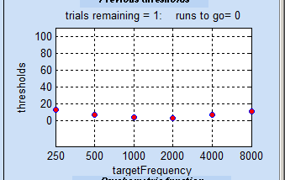 | Name: John doe  paradigm: absThreshold  Ear: MAPmodelSingleCh  method: oneIntervalUpDown  date: 13-Sep-2011 08_26_12  thresholds  targetFrequency/ targetDuration  0.25  250 13.3928  500 7.0523  1000 3.7604  2000 3.4448  4000 7.727  8000 11.3222
- And that concludes the measurement of the absolute thresholds.

Tuning curves
The next paradigm measures frequency selectivity. By this I mean the tendency of tones at one frequency to be masked by others. To measure this we use a forward masking procedure. The patient is asked to listen for a brief tone following a masking tone at the same or (more often) a different frequency. If the masking tone is intense enough, it will render the probe tone inaudible.
The measurement goal is to discover just how quiet the masker can be while still preventing the listener from hearing the probe. The test is repeated with different frequency maskers. For normal hearing, the masker is most effective when it is close in frequency to the tone. When the masker frequency is remote from the probe frequency, the masker should be much less effective or even completely ineffective.
In this paradigm, the masker is a 100-ms pure tone with a 4-ms onset and offset ramp. This precedes the probe tone by 10 ms. The multiThreshold software varies the level of the masker to discover the level of the masker that just masks the probe.
In practice, the listener is asked to listen for the probe tone and ignore the masker. This may take a little getting used to but is simple enough. When the probe is present, it is heard as a ‘click’ or ‘rough edge’ at the end of the masker beep. A cue interval is presented first when the ‘click’ should be clearly audible because the masker is less intense. This is immediately followed by the test when the probe tone either is present or is omitted.
The instruction to the listener is to count the number of intervals when the trailing click is heard. Normally, this is audible during the cue interval so the listener should report at least one trailing click. If this is audible in both intervals, the response should be to hit the ‘2’ button on the subject GUI. This is easier to demonstrate than to describe in words.
The probe tone is always a 16-ms pure tone with 4-ms onset and offset ramps. The level of the tone is 10 dB above the patient’s threshold for the tone. This means that we must begin my measuring the threshold for this tone. Once this is done we can begin with the tuning curve proper.
- Obtain the absolute threshold for a 16-ms probe tone at 1 kHz by selecting the absThreshold_16 paradigm from the paradigm pup-up menu. Notice that the duration has now changed to 0.016.
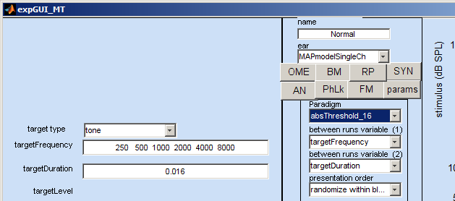
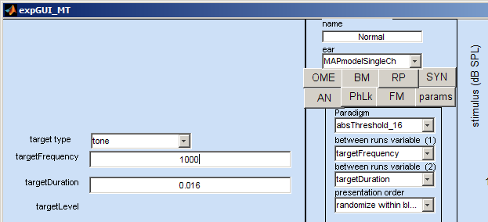
- The paradigm gives 6 frequencies but we want only need one (1 kHz), so we must delete these frequencies and replace them by a single value (1000).
- Establish the threshold in the same was as we have before. This will be quite quick because the tone is short and the patient is, by now quite skilled.
- Let us say that the obtained threshold is 8 dB SPL. We can use this to specify the probe level for the tuning curve measurement. This is set at 10 dB above threshold and, in this case will be 18 dB SPL.
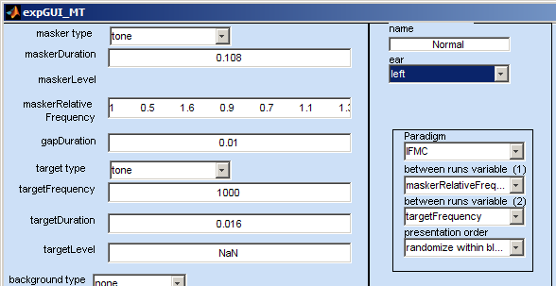
- We can now proceed to the actual tuning curve measurement. Select the ‘IFMC’ paradigm from the paradigm pop-up menu. Many more boxes will appear because this paradigm involves a masker in addition to a probe. Fortunately, the software fixes most of them. Make sure that the targetFrequency is 1000. Change it if it is not.
- We are almost ready to go but notice that the targetLevel box contains the mysterious value ‘NaN’. This is MATLAB speak for ‘not a number’. This is where we must put our probe level. Type in ‘18’ or whatever value is 10 dB above the threshold for the probe tone alone.
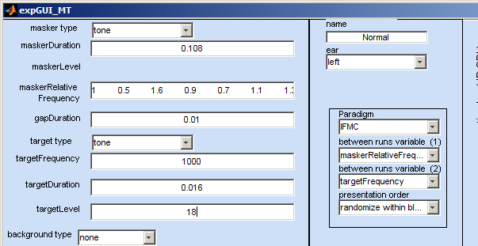
- We can start the measurements by clicking on the ‘run’ button. This will open the subject GUI and the subject should click on ‘GO’ to hear the first stimulus.
- This typically begins with quiet maskers which may be inaudible. The stimulus presented is shown in the stimulus box to the top right of the experimenter GUI. If the listener has understood the instructions, he should hear two probe tones and will respond by clicking on the ‘2’ button. He may hear nothing at all, of course. Simply because a sound is above absolute threshold does not mean that it will always be audible! This may sound like a paradox but it is simply a matter of attention and knowing what to expect. A few repeat trials (click on the ‘repeat’ box) will gradually give the listener the chance to become familiar with what is happening and the problem should not recur.
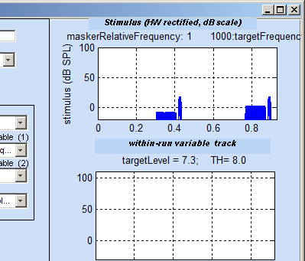
- In the following trials, the masker level is raised or lowered according to the patient’s response. If the test probe is heard, the masker is made more intense. If it is not heard, the masker is made less intense. Catch trials are included and serve the useful purpose of checking that the listener really has understood the instructions. If a probe is reported when none was presented, the run is aborted and we begin again from the beginning. It is important that the listener only clicks on the ‘2’ button when he is certain that he has heard both probes.
- The measurements will be automatically repeated for different masker frequencies to discover how frequency affects the ability of the masker to mask the probe tone. The frequency and level of the probe remains fixed throughout. The masker frequencies are specified relative to the fixed probe frequency. The relative frequencies are shown in the maskerRelativFrequency box on the experimenter GUI. These are by default ; 1 0.5 1.6 0.9 0.7 1.1 1.3. Multiply these numbers by 1000 to get the actual frequencies.
- The measurements should take about 5-10 min. The results are plotted on the GUI and printed out in the command window. For normal hearing, this should form a V-shape; the more remote the masker frequency from the probe frequency, the less it’s masking ability and the greater the level required to prevent the probe from being heard.
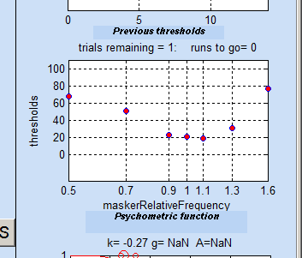 | Name: John Doe  paradigm: IFMC  Ear: MAPmodelSingleCh  method: oneIntervalUpDown  date: 13-Sep-2011 09_26_14  thresholds  maskerRelativeFrequency/ targetFrequency  1000  0.5 68.2657  0.7 50.8073  0.9 23.2154  1 21.0801  1.1 18.6945  1.3 30.8803  1.6 76.5877
- If you are reasonably sure that your hearing is normal but you do not obtain a V-shape, do not despair because this procedure requires a little practice. When testing a patient, a little encouragement may be in order because the task is so unfamiliar. A useful tip is to click on the ‘2’ button only when absolutely sure that the trailing probe has been heard. When unsure, always choose the ‘0’ or ‘1’ button. Some listeners (particularly those with some psychophysical training) persist in clicking on ‘2’ even during catch trials when no probe is present. This either means that they do not understand the distinction between the probes and the ‘distracting beeps’ or that they are trying too hard to hear something. Repeating the instructions or a short discussion will normally clear up the problem.
- The procedure can now be repeated using different probe frequencies. Note that you will need to measure the threshold of the probe tone afresh for each probe frequency used.

Compression
The normal ear has a natural tendency to compress the level of the sounds it is processing. In the mid-level region, this can be as great as 0.2 dB/dB. In some impaired hearers, it can be largely absent so that the internal representation of the sound grows at the same rate as the sound itself. It is time-consuming to put a numerical estimate on the amount of compression and most methods are controversial. However, multiThreshold can measure it to the extent that it can be compared with normal hearing.
The technique is similar to the tuning curves method described above and uses a masker followed by a test probe. However, in this case the masker and the probe always have the same frequency. What changes is the time interval between the two. For the tuning curve, the gap was fixed at 10 ms. For the compression estimate, the gap varies between 10 and 90 ms.
As the gap increases, the masker will need to increase in level to maintain its ability to prevent the test probe from being heard. The rate at which it increases is indicative of the amount of compression. A steep rise indicates that the masker is being compressed. If the rise is shallow, the masker is not being compressed and a small increase in the masker is producing a large internal change, enough to mask the probe.
- Select ‘TMC’ from the paradigm pop-up menu.
- The probe level used in this test is the same as for the tuning curves, i.e. 10 dB above the absolute threshold for the probe. If we measure compression at 1-kHz, we can use the same probe level (18 dB SPL) as we did in the previous example. Put this value in the targetLevel box. Make sure that the targetFrequency is 1000. If not, change it.
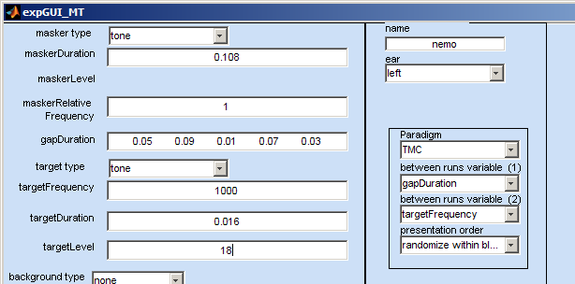
- The measurements proceed as for the tuning curve. The listener counts the number of trailing clicks. A number of measurements are made (at different gaps) and the listener has to click on ‘GO’ between each run.
- When all of the measurements are complete, the masker levels are plotted against gap duration. Good compression is indicated by a steep rise. In this case a rise of 60 dB can be seen. For some hearing impaired listeners, the rise can be as small as a few dB (<10) so the difference is quite marked. Impairment is not necessarily the explanation if a low rise is obtained. Other explanations are possible. Compression is only observed in the mid range where ‘mid range’ is poorly defined. However it can be seen that the rise between gaps 10 and 30 ms is very small (only 1 dB). This is because the masker level is too low to show the effect.
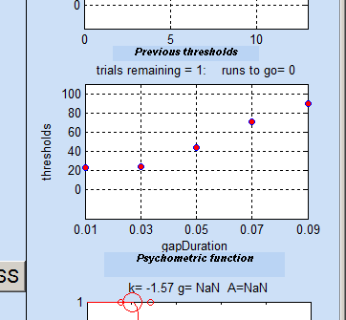 | Name: John Doe  paradigm: TMC  Ear: MAPmodelSingleCh  method: oneIntervalUpDown  date: 13-Sep-2011 11_54_20  thresholds  gapDuration/ targetFrequency  1000  0.01 22.83  0.03 23.8216  0.05 44.1472  0.07 70.791  - 89.4251
- The procedure can now be repeated using different probe frequencies. Note that you will need to measure the threshold of the probe tone afresh for each probe frequency used.

